In Infants: When delivered through the infected birth canal they get infected (perinatal transmission)
Manifestation: Gonococcal ophthalmia neonatorum affecting the eyes.
If untreated and complicated, it leads to blindness.
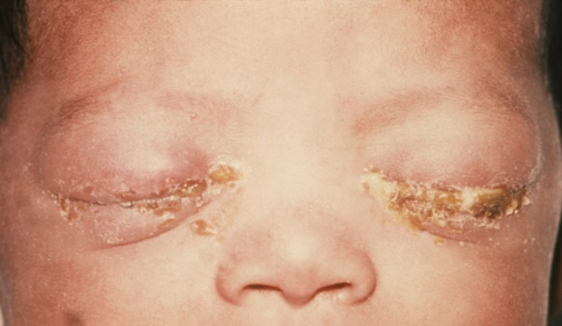

DIAGNOSIS AND TREATMENT
Route of transmission:
- Sexual Contact
- Perinatal transmission
Specimen: Urine and Swabs (Urethral, cervical, and Eye)
Laboratory Diagnosis:
- Smears examined under the microscope
- Culture in vitro
- Biochemical tests
- Serology
- Polymerase Chain Reaction (PCR)
Treatment:
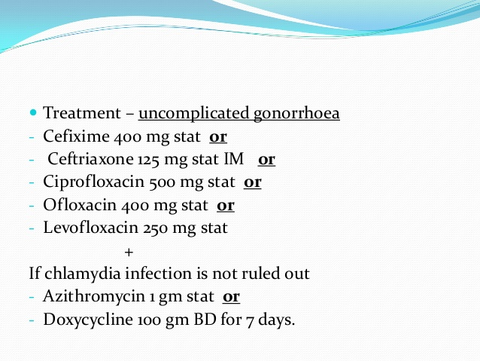
PATIENT PROGNOSIS
Disease is curable!!
- Full recovery with treatment
- Complications and even death without treatment

INCIDENCES
Approximately 20 million new STIs each year in the United States of America, half of the cases of which are among the adolescents age 15-24 years

FUN FACTS!
Gonorrhea or Greek origin, “gono” meaning “seed” and “rhea” meaning “flow” because early physicians thought the discharge was actually semen!!!

Introduction

Background: Discovery of the Disease

WHO: By Albert Ludwig Sigesmund Neisser

When: 1879

How: Albert Neisser isolated and visualized N. gonorrhoeae diplococci in samples of pus from 35 men and women with the classic symptoms of genitourinary infection with gonorrhea – two of whom also had infections of the eye.

Where: Not disclosed!

Background: Discovery of the Disease

Causative Agent/ Microbe

Symptoms

Diagnosis and Treatment

Incidence

Patient Prognosis

Gonorrhea

Date of publication
CAUSATIVE AGENT

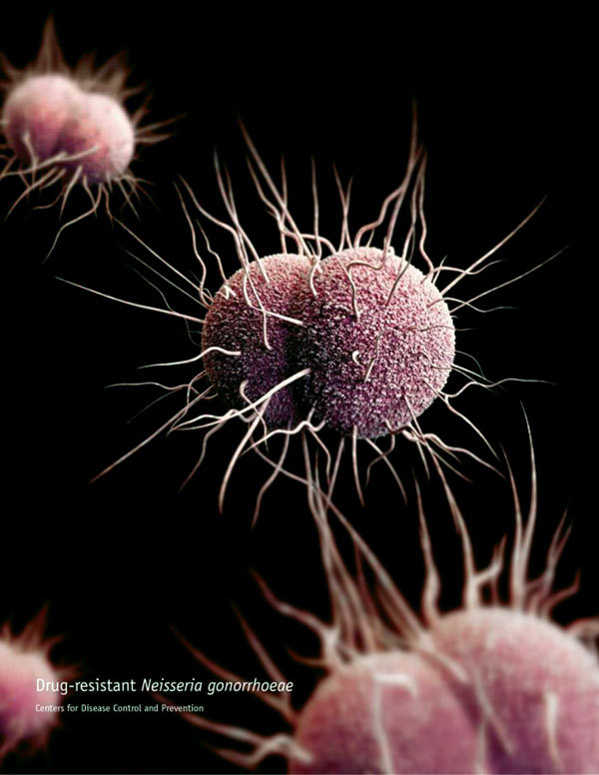
A 3-dimensional computer-generated image of drug-resistant Neisseria gonorrhoeae diplococcal bacteria. Source: Public Health Image Library.
- Neisseria gonorrhea
- One of the only two Neisseria species that cause diseases in humans
Unique Characteristics:
- Gram-negative, non-motile, intracellular diplococcal bacterium
- Ability to survive inside neutrophils
- Killed rapidly by drying, sunlight, heat, and disinfectants.
- Ferments carbohydrate producing acid but no gas.
- Each cocci is kidney-shaped with adjacent concave sides.
- Fastidious bacterium that grows best on complex media such as enriched agar(chocolate agar) with various antimicrobials (Thayer-Martin) under aerobic conditions containing 5% CO2
- Oxidase positive.
- Obligate parasite of the human urogenital tract.
- It exhibits antigenic variation through recombination of its pili and surface proteins that interact with the immune system.

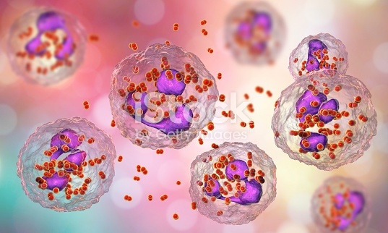Bacteria Neiserria gonorrhoeae inside phagocytes, gonococcus, diplococci which cause sexually transmitted infection gonorrhea. 3D illustration of incomplete phagocytosis. Courtesy of essentials collection

Symptoms

Clinical Manifestations

Male: gonococcal urethritis
Complication:
- Urethral stricture
- Gonococcal epididymitis,
- Gonococcal epididymo-orchitis, Infertility,
- Gonococcal suppurative arthritis (septic arthritis) and
- disseminated gonococcemia - endocarditis, meningitis, or gonococcal dermatitis-arthritis syndrome.

Female: Gonococcal cervicitis and Gonococcal salpingitis

COMPLICATION:
- Gonococcal tubo-ovarian abscess
- Pelvic Peritonitis
- Infertility (10-20% of the cases)

General signs and Symptoms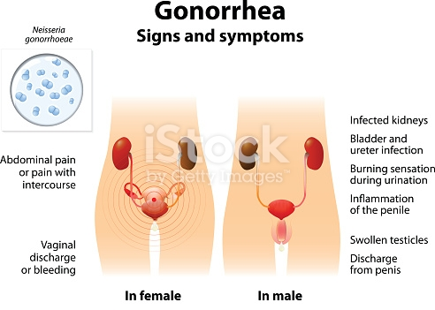
Company Name
Street Address
Address 2
City, ST ZIP Code
Phone (555)555-0125
Fax (555)555-0145
Web site address

